Short-beaked common dolphin (Delphinus delphis) mortality.

The short-beaked common dolphin (Delphinus delphis) is one of the most abundant cetacean species in the eastern North Atlantic (SCANS-II, 2008). It is considered a single population since no evidence of genetic structuring has been found in the area (e.g. Murphy et al., 2013). Some life history parameters: sexual maturity, life expectancy and pregnancy rate have been derived from postmortem data obtained from stranded and by-caught individuals. In addition to these, parametres such as mortality-at-age are unknown but needed to estimate population dynamics.

Previous analysis were made applying some approaches for estimating natural mortality in long-living species, based on the longevity (Hoenig, 1983; Hewitt and Hoenig, 2005) and weight (Charnov, 1993) (Table 1).

Table 1: Mortality models for long-lived species. Based on the longevity (Hoenig, 1983; Hewitt and Hoenig, 2005) and weight (Charnov, 1993)

Nevertheless, it is known that marine mammals show a different mortality rate according to age, suffering high mortality at young ages, followed by lower and constant mortality which increases again at older ages. For this reason, mortality rate in mammals has been usually approximated using life table methodology (i.e. Pierce et al., 2013, poster Setubal, Read et al., 2012, harbour porpoises ASCOBANS report). A life table is a vector of age-specific survival or mortality rates, and represents an important tool for understanding the demography of populations (Stolen and Barlow, 2003). Survivorship and mortality can be infered directly by following one or more cohorts through time, or indirectly from analysis of an age distribution of living individuals (Caughley, 1966; Barlow and Boveng, 1991) or from the age distribution of deaths (Caughley, 1966; Spinage, 1972).

Although widely used for terrestrial and some marine mammals (Spinage, 1972; Hewer, 1974; Marmontel, 1993), few mortality models based on life tables have been constructed for cetaceans (Olesiuk, 1990; Barlow and Boeng, 1991; Brault and Caswell, 1993; Barlow and Clapham, 1997; Stolen and Barlow, 2003) .

Using data from stranded animals we can construct life tables that, although they may have some restrictions, are often approximated well enough for practical purposes (Stolen and Barlow, 2003). Based on this assumption, we constructed a life table from data from stranded carcasses from Galician coast (Northwest Spain) colected by CEMMA (Coordinadora para o Estudio dos Mamíferos Mariños) from 1990 to 2010, and age-at-death data estimated by Fiona Read by counting the age layer groups present in the teeh gathered from the carcasses.

However, the possible biases arising from the use of stranding data should be taken into account. For example, not all carcasses might arrive at the coast, especially those of small/younger animals that could be more vulnerable to predation, more rapidy decomposed and/or have lower detection probability (Stolen and Barlow, 2003). For this reason, several models have been used to fit a smooth age-specific mortality function such an exponential model, general linear model (GLM) family Poisson, a second-degree polynomial and the Siler function (Siler, 1979), using a maximum likelihood method.

The number of strandings were fitted with an exponential, a GLM family Poisson and a second-degree polynomial models. In all cases, the models were first run with all the available data and afterwords models were rerun after removing the younger age classes sequentially (Figure 1).
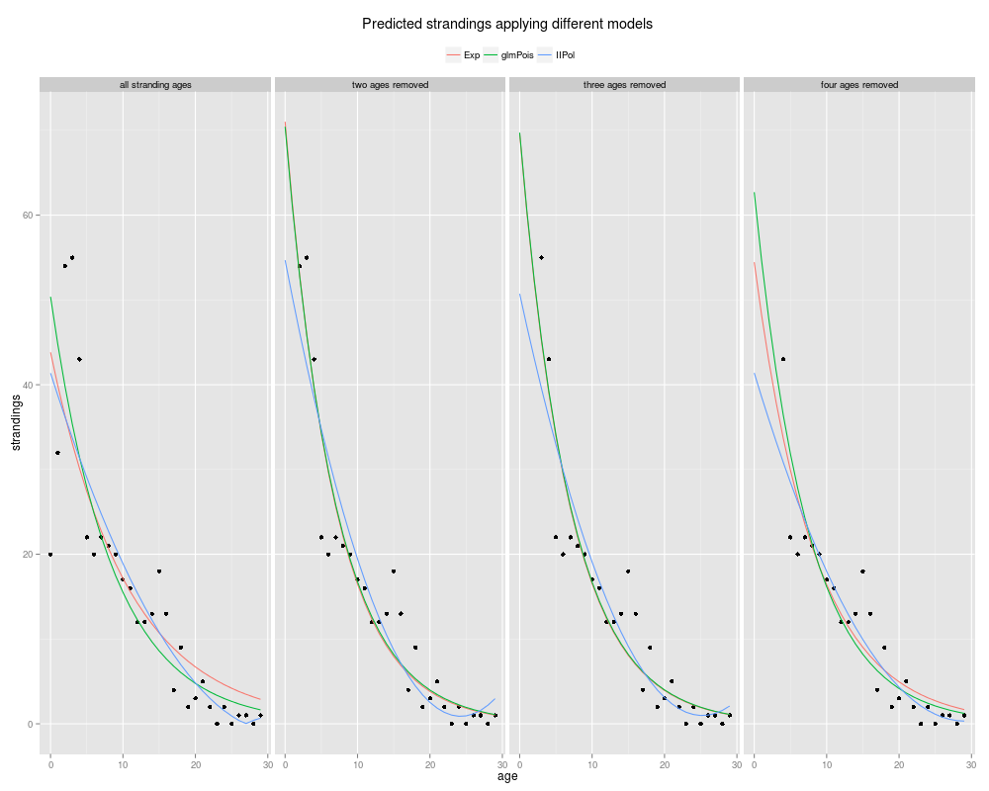
Figure 1: Predicted strandings applying different models: Applying an exponentical model (red), a GLM family Poisson model (green) and a second-degree polynomial model (blue). Values fitted from the actual strandings values and by removing first age classes (two, three and four age classes).

Although models fitted by removing both two and three age classes are similar, predicted figures for the first age classes are slighly high in the first case, however, models that had the three younger age classes removed may be more realistic since strandings of age class 2 seem lowere than would be expected. Predicted values are shown in table 2.

While the exponential and GLM give similar fits, the second-degree polynomial model overfits some values and gives unreal figures, chiefly in the last age classes. Between the exponentical and the GLM has been choosen the GLM because it does not assume normality and heteroscedasticity of the residuals. Note that their differences are evident when these assumptions are violated in the exponential model fitted without removing ages classes. See Normal Q-Q plot and Cook's distance for the GLM fits in the figure 2.

Table 2: Number of strandings and predicted strandings-at-age: Strandings from 1990 to 2010 (n). Predicted strandings by fitting an exponential model (Exp), general linear model family Poisson (glmPois), second-degree polynomial model (IIPol). Values fitted from the strandings values and by removing he younger age classes.

Figure 2: GLM residual analysis. Residual vs Fitted, Normal Q-Q, Scale-Location, Residuals vs Leverage plots of the GLM fitted with the actual data and the data whit first two, three and four age class removed.

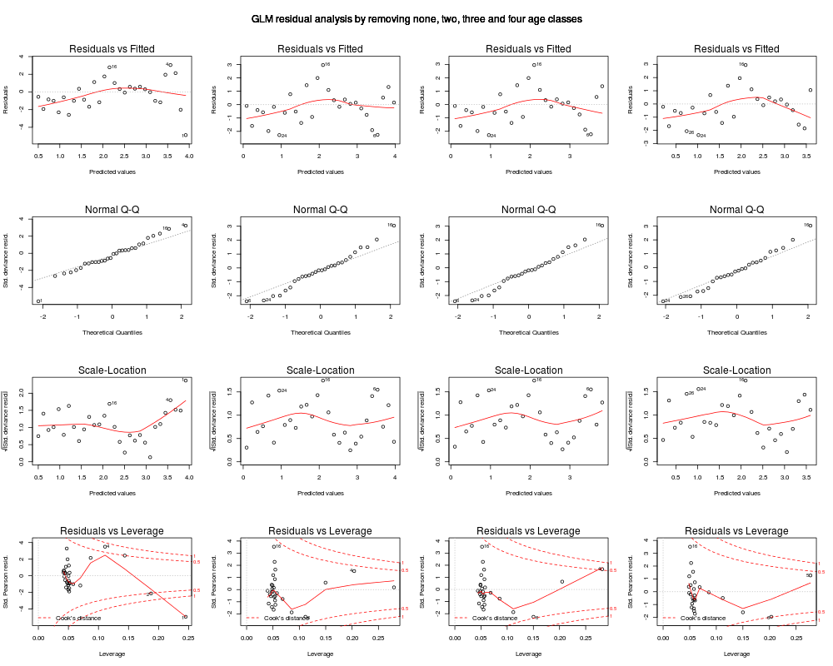
Two life tables were constructed from actual strandings and the strandings predicted with the GLM after the youngest three age classes were removed (Tables 3 and 4). Survivorship and mortality curves predicted with the life tables are shown in figure 3.

Table 3: Life table constructed from actual strandings data. age: Age of the dolphin. M: Dolphins stranded at age x. S: Survivors at the start of the age x. nx: Standardized survivors (by n=1000) [(S/∑M) * 1000]. dx: Standarized death-at-age [nx – n(x+1)]. qx: Death-at-age probability [dx / nx]. lx: Survivors-at-age percent [nx / n]. ex: Life expentancy at age [∑ly/lx]. Z: Total mortality [(-log(S)/(S-1))/t].

Table 4: Life table constructed from predicted strandings with GLM fitted by removing first three age classes. age: Age of the dolphin. M: Dolphins stranded at age x. S: Survivors at the start of the age x. nx: Standardized survivors (by n=1000) [(S/∑M) * 1000]. dx: Standarized death-at-age [nx – n(x+1)]. qx: Death-at-age probability [dx / nx]. lx: Survivors-at-age percent [nx / n]. ex: Life expentancy at age [∑ly/lx]. Z: Total mortality [(-log(S)/(S-1))/t].

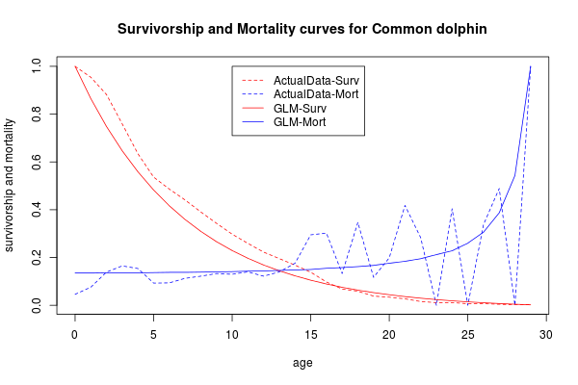

Figure 3: Survivorship and mortality curves for common dolphin. Actual data survivorship curve (dashed red line), actual data mortality curve (dashed blue line), predicted GLM data survivorship curve (red line), predicted GLM data mortality curve (blue line).

To fit the negative exponential model, the youngest two first age classes were removed (ages 0 and 1). Ages from 2 to 8 (inmature animals) were used to fit the model. Constant mortality corresponded to the age with less mortality (age 5) regardless of age with zero mortality. Positive exponencial model for senescence animals was fitted using ages form 8 to 29. Age 8 was used to fit juvenile and senescence mortality because it is the age at which half the animals are mature (Figure 4). A life table was recalculated using mortality-at-age from Siler model (Table 5).
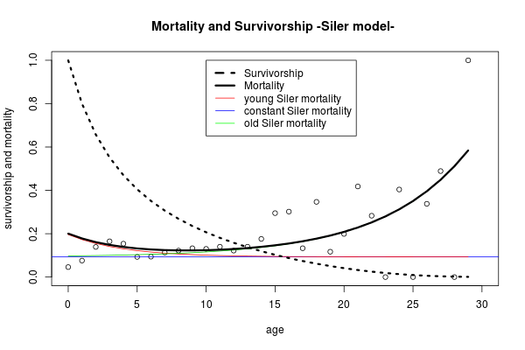
Figure 4: Mortality and survivorship fitted with Siler competing-risk model. Survivorship curve (black dashed line). Siler mortality (black line). Juvenile mortality (red line). Constant mortality (blue line). Senescence mortality (green line).

Table 5: Life table calculated from the mortality (qx) from the Siler model. age: Age of the dolphin. nxS: Standardized survivors (by n=1000). dxS: Standarized death-at-age. qxS: Death-at-age probability. lxS: Survivors-at-age percent. exS: Life expentancy at age. ZS: Total mortality-at-age.

Once the life tables have been constructed, we can calculate an initial population structure with the 15000 dolphins estimated for the Iberian Peninsula (4/5 of the W block) (SCANS II, 2008) by multiplying the percentage of dolphins per age of the three life tables by the total population (Table 6).

Table 6: Population structure: Population structure with a total abundance of 15000 dolphins calculated with the actual strandings data (n), the population estimated with the GLM model with the three first age classes removed (GLM02) and the Siler model with the two first age classes removed (Siler01).

A maturity ogive was fitted to calculate the amount of mature females in our population. We fitted a Binomial GLM used for binary of data (presence-absence, mature-inmature) over the whole dolphins (males and females). Three anomalous data points (inmature females older than 10 years) were removed from the dataset and models were rerun without them. The removal of these females was performed assuming that a maturation problem might have occurred by some kind of sickness since these are stranding animals. A50 (age at which half of the dolphins have achieved maturity) of the first ogive was 8.58 years old and 7.86 for the second (Figure 5).

Separate ogives for males and females were constructed. The ogive for females was fitted withouth the three anomalous data points mentioned earlier. The male model did not converge and this may have been due to the scarcity of data available. The A50 were 8.57 and 7.03 respectively (Figure 6).
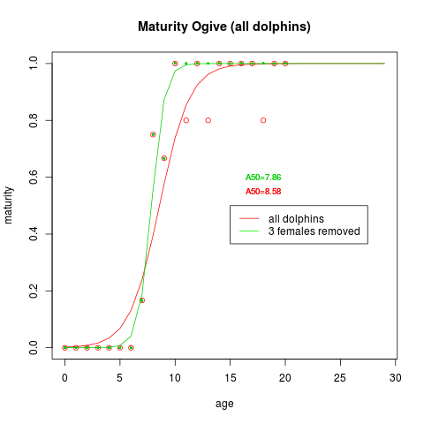
Figure 5: Maturity ogive (all dolphins). All dolphins maturity ogive (red line) and all dolphins maturity ogive were the three anomalous data points were removed (green line). A50 for the two models.
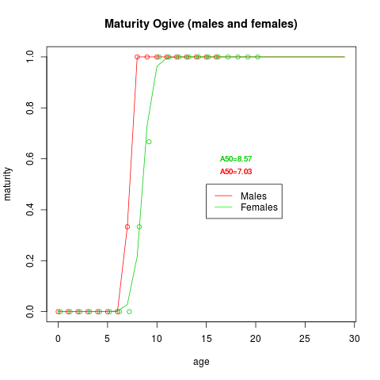
Figure 6: Maturity ogive (males and females). Males maturity ogive (red line) and all dolphins maturity ogive were the three anomalous data points were removed (green line). A50 for the two models.

Three maturity vectors are shown in table 7. The table includes the percentage of mature dolphins (both sexes combined) and by sex after the three anomalous female data points were removed.

Table 7: Maturity vectors. Percentage of mature dolphins (both sexes combined) and by sex after the three anomalous female data points were removed.

It is assumed that the sex ratio in our population will have the same percentage of males and females (1:1). Therefore, if we divide the dolphins of each age by two we will get the females abundance per age. Multiplying this amount by the maturity vector we will get the mature females but, since we want to calculate the number of females who could give birth we must remove the females of each age class which will die in the current year or to move up the maturity vector a year, assuming approximately a one-year gestation (Murphy, 2013) and remove the last age as these dolphins do not give birth next year. Furthermore, we have to divide this data by the pregnancy rate since not all the females will give birth each year. Pregnancy rate is an imprecise index about 25-33% (Murphy, 2013), thus we have calculated the number of birth by applying three different pregnancy rates (25, 33 and 50%). Births estimated by each model are shown in table 8.

Table 8: Number of births. Calculated with three different pregnancy rates (25, 33 and 50%) and the stranding data (n), the population estimated with the GLM model with the three first age classes removed (GLM02) and the Siler model with the two first age classes removed (Siler01).

